VAPT MINI PROJECT REPORT
Cover Page
Student Name: K. Hemalatha
Assigned Target: PortSwigger Web Security Academy Lab
Target: 0ad6006c038d4506801a8584006d0063.web-security-academy.net
Project: Vulnerability Assessment and Penetration Testing
Tools Used:
- Kali Linux
- Nmap
- Burp Suite
- Web Browser
- PortSwigger Web Security Academy

1. Scope & Objective

Scope
The assigned target for this VAPT assessment was the PortSwigger Web Security Academy lab:
0ad6006c038d4506801a8584006d0063.web-security-academy.net
The testing was limited to the assigned authorized lab target.

Objective
The objective of this assessment was to follow the standard VAPT lifecycle by performing reconnaissance, port and service scanning, vulnerability identification, exploitation, impact demonstration, and security risk assessment of the assigned target.

2. Discovery
The discovery phase was performed to identify and confirm the assigned target and determine whether it was reachable.

Commands Used
ping -c 4 0ad6006c038d4506801a8584006d0063.web-security-academy.net
nslookup 0ad6006c038d4506801a8584006d0063.web-security-academy.net

Result
The target hostname was successfully resolved and the target was reachable. This confirmed that the assigned target was available for further assessment.

Screenshot

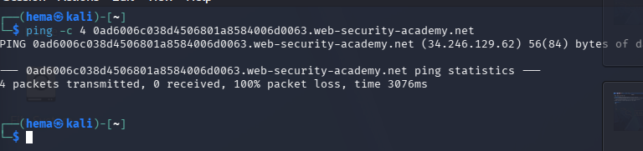
3. Port & Service Scan
The port and service scanning phase was performed to identify open ports, running services, and their versions on the assigned target.
Scan Command
nmap -sV 0ad6006c038d4506801a8584006d0063.web-security-academy.net
The -sV option was used to perform service and version detection.
Screenshot
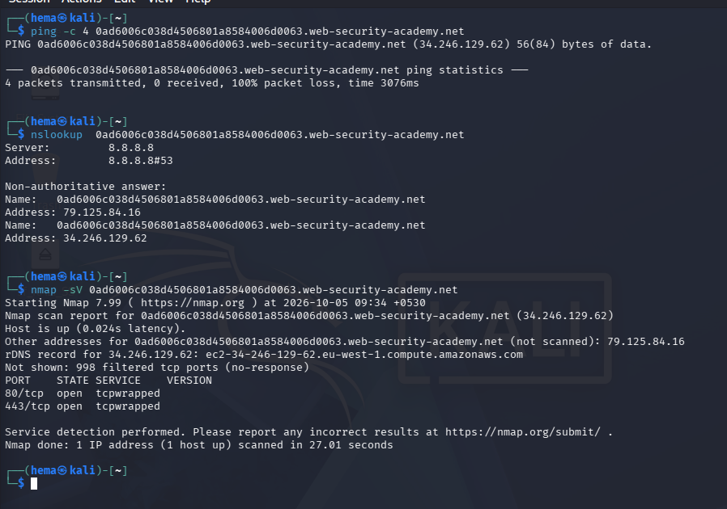

Result
The identified open ports and services were recorded for further vulnerability analysis.
4. Vulnerability Analysis
The vulnerability analysis was performed based on the behavior of the assigned PortSwigger Web Security Academy target. The identified vulnerability was a SQL Injection vulnerability in the login functionality that allows authentication bypass.
Finding 1 — SQL Injection / Login Bypass
Affected Component:
Login functionality / username parameter
Vulnerability:
SQL Injection
Associated CVE(s):
No specific CVE was identified for this PortSwigger lab vulnerability. The issue is an application-specific SQL injection vulnerability.
Description
The application's login functionality accepts user-controlled input through the username field. By providing a specially crafted SQL injection payload, the authentication query can be manipulated.
The payload used during testing was:
administrator'--
The -- portion is used to comment out the remaining part of the SQL query, allowing the normal authentication logic to be bypassed.
Evidence
The modified request resulted in:
HTTP/2 302 Found
Location: /my-account?id=administrator
This response demonstrated that the application accepted the manipulated input and redirected the request to the administrator account.
Why It Is Exploitable
The vulnerability is exploitable because the application does not properly separate user input from the SQL query used for authentication.
Screenshot
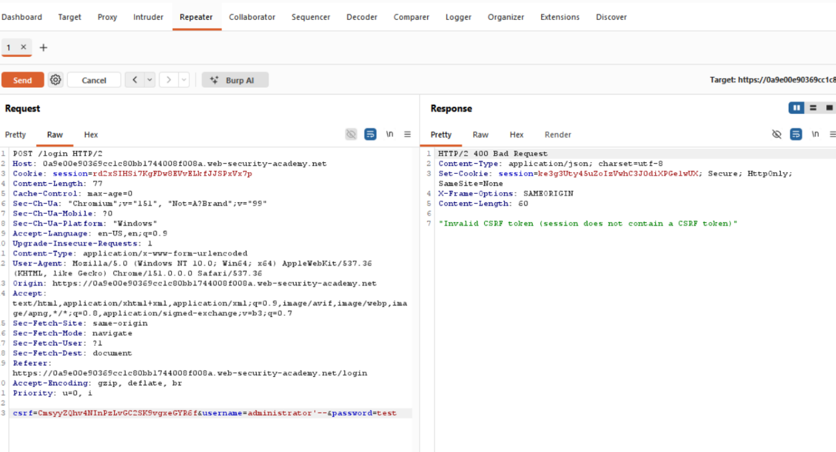
5. Exploitation
The identified SQL Injection vulnerability was tested using Burp Suite Repeater against the assigned PortSwigger Web Security Academy lab.
Step 1 — Access the Login Page
The login page of the assigned target was opened in the web browser.
Screenshot:
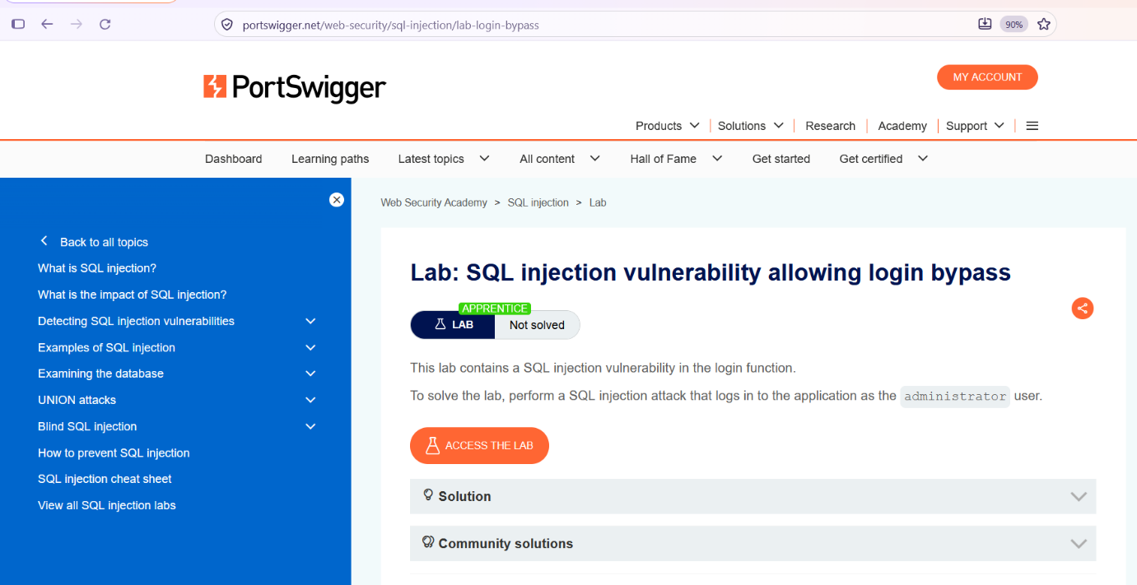
Description:
The login page was identified as the authentication interface of the application and was selected for further testing.

Step 2 — Capture the Login Request
The login request was captured using Burp Suite.
The request contained parameters including:
username=administrator
password=test
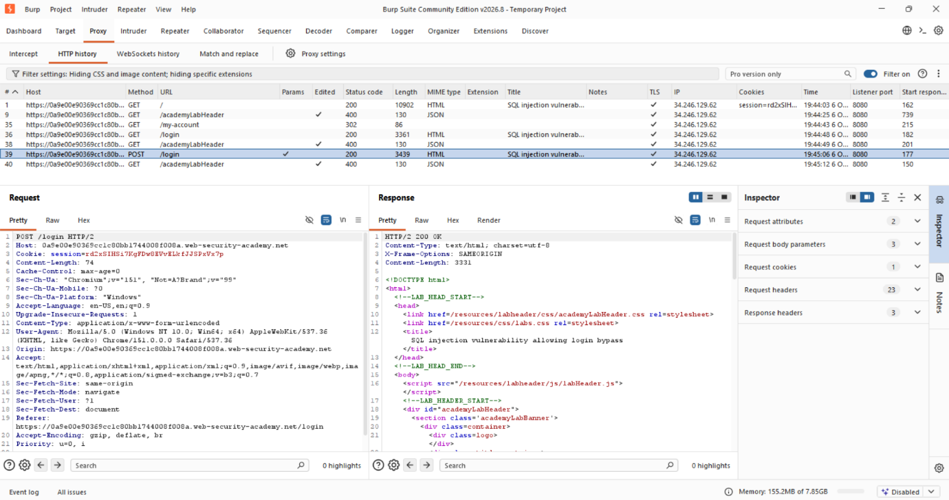
Description:
The captured HTTP request showed that the username and password were submitted to the application. The username parameter was selected for SQL injection testing.

Step 3 — Modify the Username Parameter
The username parameter was changed to:
administrator'--
The password remained unchanged.
Screenshot:
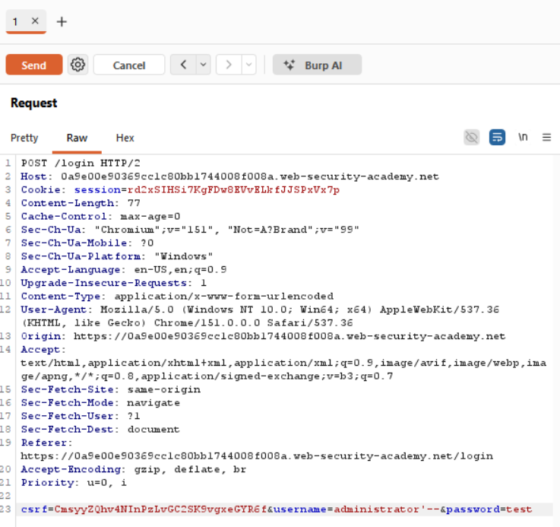
Description:
The username was modified with a SQL injection payload. The payload was designed to alter the SQL query and comment out the remaining portion of the query.

Step 4 — Send the Modified Request
The modified request was sent using Burp Suite Repeater.
The server returned:
HTTP/2 302 Found
Location: /my-account?id=administrator
SCREENSHOT
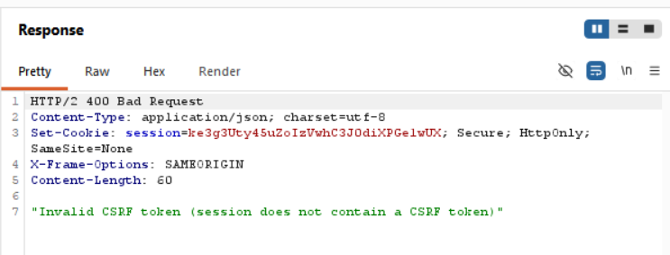
Description:
The 302 Found response redirected the request to /my-account?id=administrator. This demonstrated that the SQL injection payload successfully bypassed the application's authentication mechanism.

Exploitation Result
The SQL injection vulnerability was successfully exploited using the following payload:
administrator'--
The successful redirect to the administrator account demonstrated unauthorized authentication access.
6. Demonstration & Impact
The successful exploitation demonstrated that the login authentication mechanism could be bypassed using a SQL injection payload.
The following payload was entered into the username parameter:
administrator'--
The application responded with:
HTTP/2 302 Found
Location: /my-account?id=administrator
This response demonstrated that the application redirected the request to the administrator account page without requiring the legitimate administrator password.
Impact
The vulnerability could allow an attacker to bypass the application's authentication mechanism and gain unauthorized access to protected functionality.
If exploited against a real application, an attacker could potentially access information or functionality available to the compromised account. The actual impact would depend on the privileges and sensitive data associated with that account.
Evidence
7. CVSS Scoring
The vulnerability is remotely exploitable with low complexity and does not require prior authentication or user interaction. Successful exploitation can result in unauthorized administrator-level access and potentially affect the confidentiality, integrity, and availability of the application.
- Vulnerability: SQL Injection – Login Bypass
- CVSS v3.1 Score: 9.8 (Critical)
- CVSS Vector: CVSS:3.1/AV:N/AC:L/PR:N/UI:N/S:U/C:H/I:H/A:H
- Attack Vector: Network — remotely exploitable.
- Attack Complexity: Low — simple payload required.
- Privileges Required: None.
- User Interaction: None.
- Impact: Can bypass authentication and gain unauthorized administrator access.
- Risk: May affect confidentiality, integrity, and availability of the application.
8. AWS TASK ANSWERS
8.1 Task 6 – Amazon EC2
1. What is an EC2 instance?
An EC2 instance is a virtual server provided by AWS to run applications and services.
2. What is the difference between T2 and T3 instances? When would you choose one over the other?
T3 is a newer generation of burstable instances with improved performance and efficiency. The choice depends on workload requirements, availability, and cost.
3. What does t2.micro or t2.large indicate?
These indicate the instance family and size. Larger sizes generally provide more CPU and memory resources.
4. Why is a PEM key required? What happens if it is lost?
A PEM key is used for secure key-based authentication when connecting to supported EC2 instances. If it is lost, access may need to be recovered using an alternative supported method.
5. What is the difference between a Security Group and a Network ACL?
A Security Group operates at the instance or network-interface level and is stateful. A Network ACL operates at the subnet level and is stateless.
8.2 Task 7 – Amazon S3
1. What is an S3 bucket used for?
An S3 bucket stores objects such as documents, images, backups, and application files.
2. What is the difference between a public and a private bucket? How is access controlled?
A private bucket restricts access to authorized users and services. A public bucket may allow access to anyone, depending on its permissions. Access is controlled using IAM policies, bucket policies, and public access settings.
3. What is the difference between a bucket policy and an IAM policy?
A bucket policy is attached to an S3 bucket and defines access to its objects. An IAM policy defines permissions for an AWS user, group, or role.
4. Why is it risky to leave an S3 bucket public?
A public bucket may expose confidential information to unauthorized users. If write permissions are enabled, unauthorized users may also upload, replace, or delete objects.
8.3 AWS Account Verification Issue
8.3 AWS Account Registration and Verification Challenges
During AWS account registration, I encountered several issues that prevented me from completing the EC2 and S3 practical tasks.
- Identity verification failure: AWS notified me that customer identity verification had failed and requested that I update and resubmit my verification information.
- DigiLocker verification link issue: When I attempted Aadhaar verification through DigiLocker, the verification link opened in a new browser tab and immediately closed.
- Browser troubleshooting unsuccessful: I retried the verification process using Chrome Incognito mode and checked the third-party cookie settings, but the issue continued.
- Account activation delay: AWS indicated that account activation could take time after registration. However, the unresolved identity verification issue prevented me from proceeding with the required practical work.
- EC2 practical limitation: I could not launch and test the required EC2 instance because I was unable to access the necessary AWS services.
- S3 practical limitation: I could not create and configure the required S3 bucket or verify its access settings because account verification remained unresolved.
- Need for official assistance: Further assistance from AWS Support or guidance from the project mentor is required to resolve the account issue and complete the practical tasks.
8.4 Repeated AWS Verification Process and Documentation Issue
While preparing the report in Microsoft Word, I encountered an additional difficulty documenting the AWS account verification process. The process repeatedly returned to the same verification workflow instead of allowing me to proceed.
The sequence was as follows:
- Initial AWS page: I opened the AWS account setup page to continue registration.
- EC2 account verification: When I attempted to proceed with the EC2 task, AWS required account verification to be completed.
- DigiLocker verification: I selected the DigiLocker verification option to complete the required identity verification.
- Repeated verification workflow: After attempting verification, the process returned to the same page instead of completing the setup.
- Repeated steps: When I tried again, the same sequence occurred, preventing me from moving forward with the EC2 and S3 practical tasks.
This repeated process also made it difficult to document the steps clearly in Microsoft Word, as the same pages and verification instructions appeared repeatedly. Consequently, I could not obtain screenshots showing successful completion of the AWS practical tasks.
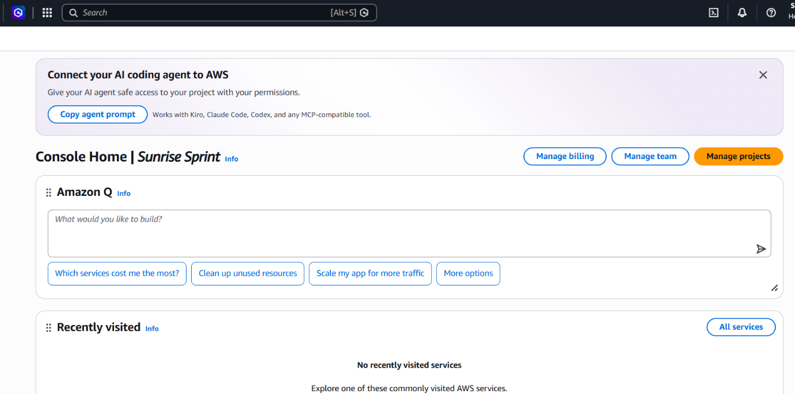
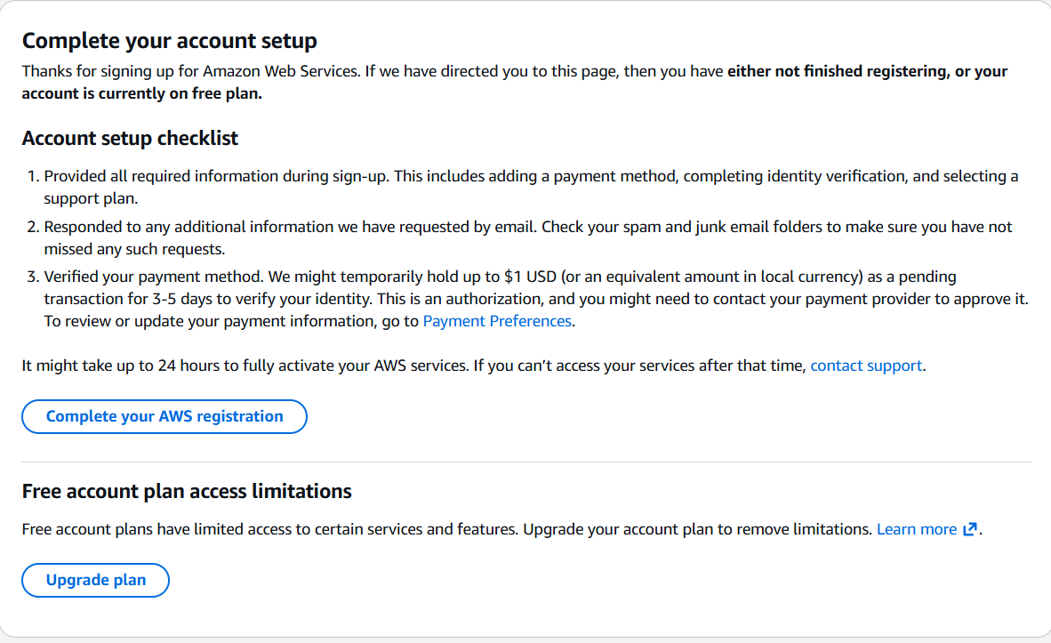
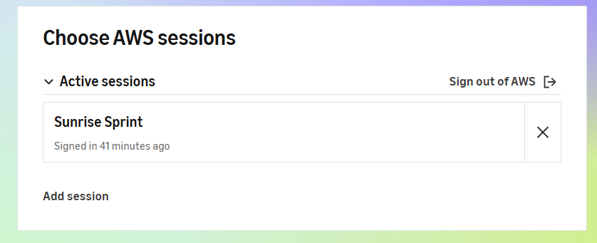

9. CONCLUSION AND RECOMMENDATIONS
Conclusion
This project examined a SQL injection vulnerability in an authorized PortSwigger Web Security Academy lab. The crafted input demonstrated a login-bypass attempt, and the observed HTTP response redirected to the administrator account page. The assessment highlights the importance of secure database queries, proper input validation, and strong authentication controls. The AWS EC2 and S3 practical tasks could not be completed due to an account identity verification issue.
Recommendations
- Use parameterized queries and prepared statements to prevent SQL injection.
- Validate user input on the server and implement strong authentication and authorization.
- Conduct regular vulnerability assessments and security testing.
- Apply least-privilege permissions when configuring AWS resources.
- Keep S3 buckets private unless public access is explicitly required.
- Resolve the AWS verification issue with AWS Support or request an institution-provided AWS account.

